
Emergency Medical
Information

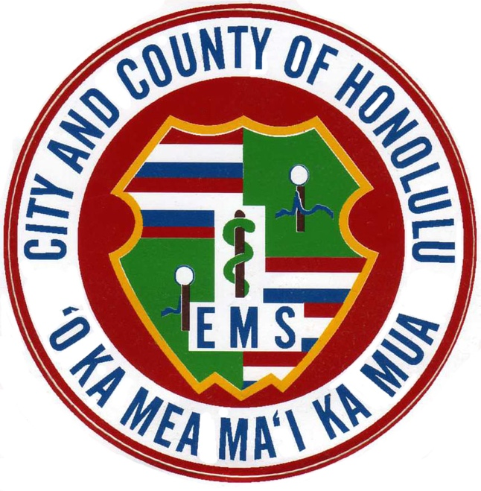
Name: Birthdate (include year):

Person to notify in an emergency:
Name: Phone:
Name: Phone:

Physician: Phone:
Allergies:
Medical Conditions:
Medications:
Blood Type:

Date Completed:7/31/268/7/22 City and County of Honolulu
Emergency Medical Services

Complete this form on your computer and print it or print this page and use a pen to complete the information.
Post it on your refrigerator or near your telephone in case of an emergency.

Fill out one card per family member. Post completed forms on your refrigerator or near your telephone in case of emergency.
Emergency Medical  Information  Name:  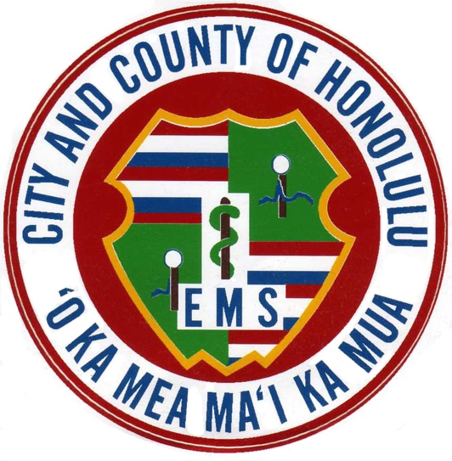  Birthdate  (include year):  Person to notify in an emergency:  Name: Phone:  Name: Phone:  Physician: Phone:  Allergies:  Medical Conditions:  Medications:  Blood Type:  City and County of Honolulu  Date Completed: 7/31/269/16/2005 Emergency Medical Services | Emergency Medical  Information  Name:  Birthdate  (include year):  Person to notify in an emergency:  Name: Phone:  Name: Phone:  Physician: Phone:  Allergies:  Medical Conditions:  Medications:  Blood Type:  City and County of Honolulu  Date Completed: 7/31/269/16/2005 Emergency Medical Services | Emergency Medical  Information  Name:  Birthdate  (include year):  Person to notify in an emergency:  Name: Phone:  Name: Phone:  Physician: Phone:  Allergies:  Medical Conditions:  Medications:  Blood Type:  City and County of Honolulu  Date Completed: 7/31/269/16/2005 Emergency Medical Services
Emergency Medical  Information  Name:  Birthdate  (include year):  Person to notify in an emergency:  Name: Phone:  Name: Phone:  Physician: Phone:  Allergies:  Medical Conditions:  Medications:  Blood Type:  City and County of Honolulu  Date Completed: 7/31/269/16/2005 Emergency Medical Services | Emergency Medical  Information  Name:  Birthdate  (include year):  Person to notify in an emergency:  Name: Phone:  Name: Phone:  Physician: Phone:  Allergies:  Medical Conditions:  Medications:  Blood Type:  City and County of Honolulu  Date Completed: 7/31/269/16/2005 Emergency Medical Services | Emergency Medical  Information  Name:  Birthdate  (include year):  Person to notify in an emergency:  Name: Phone:  Name: Phone:  Physician: Phone:  Allergies:  Medical Conditions:  Medications:  Blood Type:  City and County of Honolulu  Date Completed: 7/31/269/16/2005 Emergency Medical Services

